# Design

# Project design plan

# Structural design

## Final class diagram

## Data flow diagram

# Behavioral model

## Sequence diagram

### Login and Registration

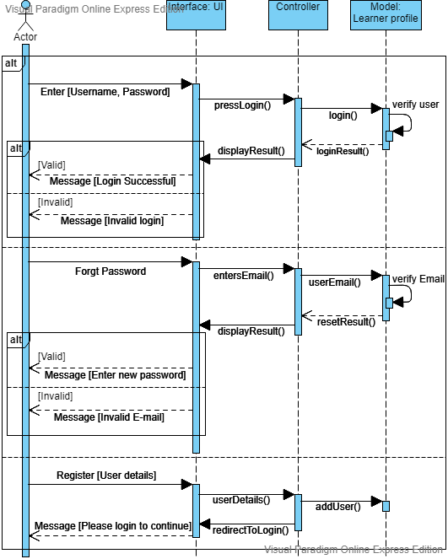

Figure 1: Login and registration

### Admin-panel

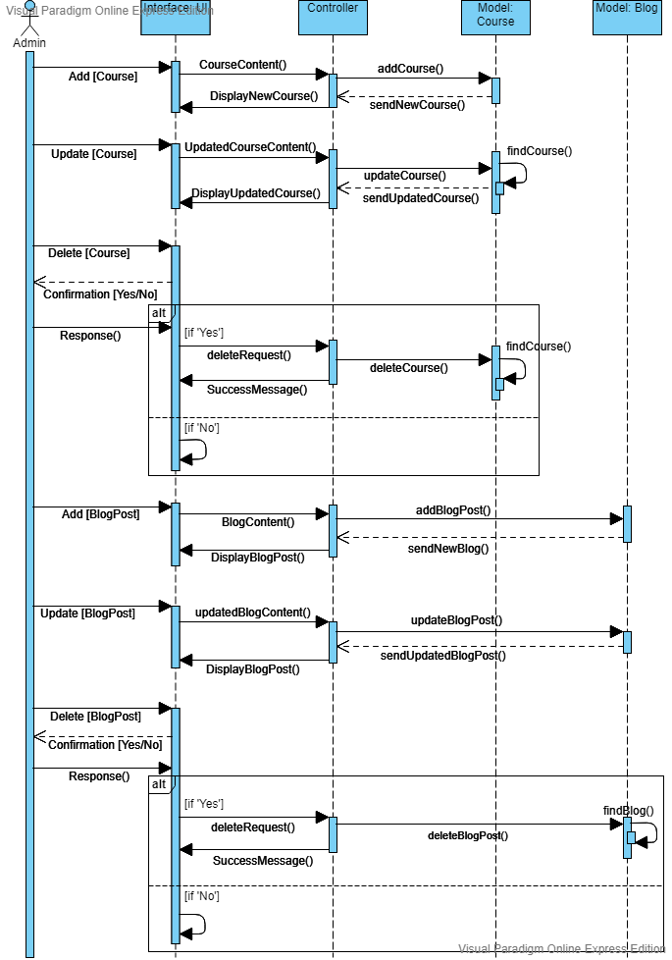

Figure 2: Admin course and blog sequence

### Learner-side

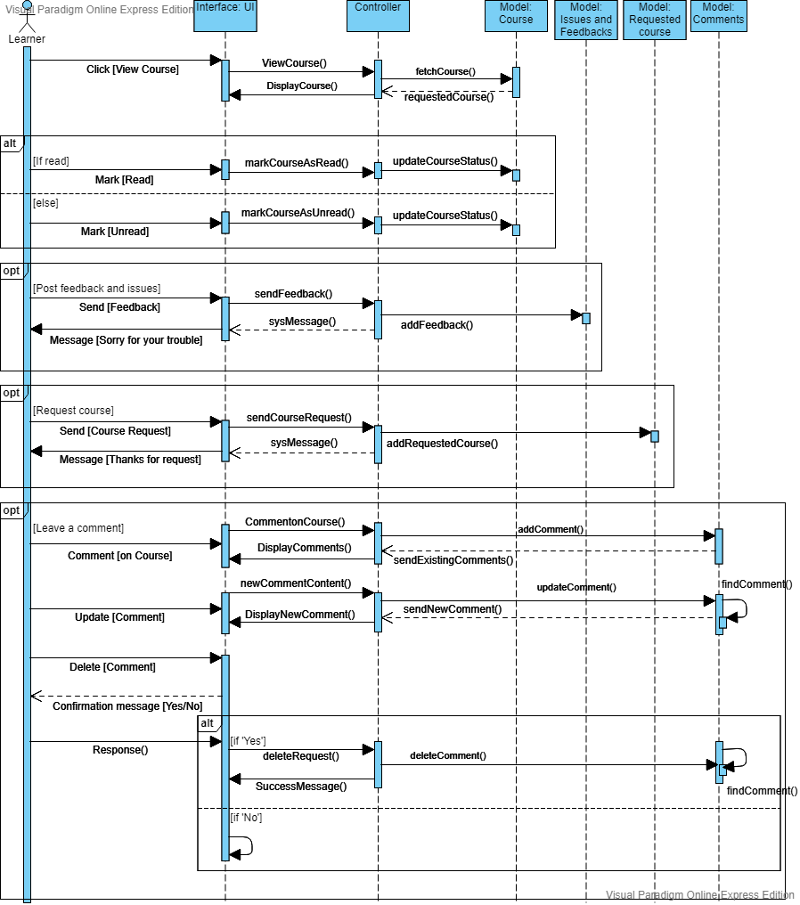

Figure 3: Learner-side sequence

## Activity diagram

### Login and registration

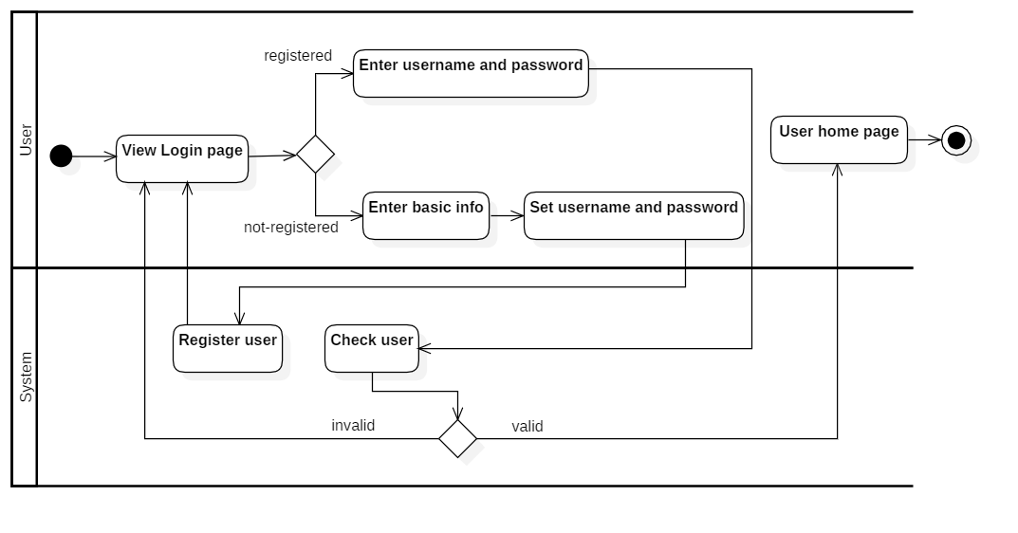

### Learner-side course

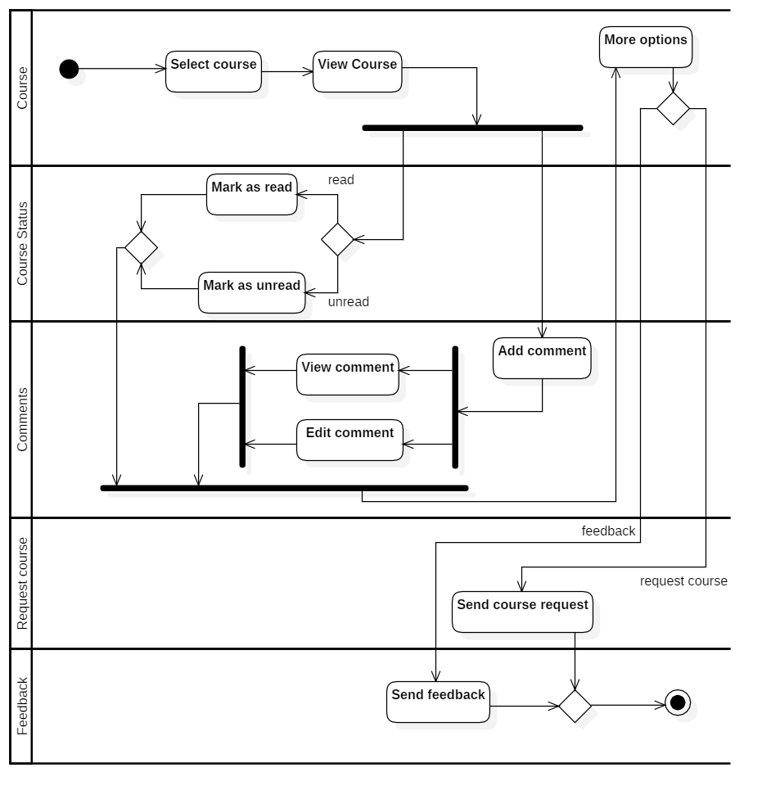

### Admin-side course

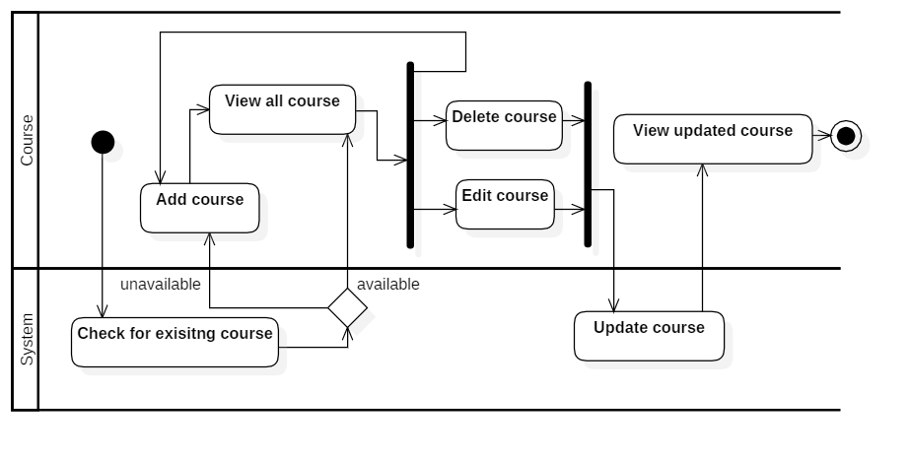

### Blog post

